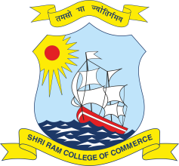 | SHRI RAM COLLEGE OF COMMERCE  University of Delhi, Maurice Nagar, Delhi – 110 007  Website: www.srcc.edu Phone: 27667905, 27666519

Date: 13.07.2020

Advertisement for the Post of Corporate and Alumni Relationship Manager

Applications are invited from deserving candidates for the post of one Corporate and Alumni Relationship Manager on Contractual Terms.
The position entails engaging and building strong, strategic and sustainable relationships with the corporate world, and the Alumni. The Resource will work as per guidelines laid by the Principal, and in close coordination with the Faculty in-charge of Placements, and Alumni at the College.
The person for this position will require at least an MBA Degree/PGD, good communication skills; interpersonal competence; organizational ability; and relevant experience.
The remuneration will be commensurate with the Work Experience and is expected to be in the range of Rs. 16 to Rs. 18 Lakhs per annum. The initial tenure of the Manager will be three years.
Interested candidates must submit the Application (Covering Letter and Curriculum Vitae) by Sunday, 4:00 pm the 19th of July, 2020 at the following email ID:
vacancies@srcc.du.ac.in
Shortlisted Candidates shall be called for an Interview. Depending upon circumstances, a Virtual Interview may be held. The selected candidate is expected to join at the earliest but not later than two months from the date of issue of the appointment letter.

PRINCIPAL

